**How does deforestation for cropland affect trace gas presence at depth in Southeastern Amazonian soils?**

Christine S. O’Connella,b,∗, Michael Coec, Eric Davidsond, KathiJo Jankowskie, P. Lefervec, Chris Neille, Rodney Ventereaf,g

aUMN, EEB; bUMN, IonE; cWHRC; dUMD; eMBL; fUSDA-ARS; gUMN, SWC

∗coconn@umn.edu

**Abstract**

Tropical soils contain large stocks of carbon (C) and nitrogen (N), but it remains poorly documented how C and N in these deep, weathered soils is affected by land use change. Evidence from the top 30 centimeters (cm) of soil indicates that land use change from forest to agriculture in the Amazon depletes C and N stocks, depresses carbon dioxide (CO2) and nitrous oxide (N2O) emissions and reduces methane (CH4) uptake; how CO2, N2O and CH4 change below 30 cm soil depth after deforestation remains poorly understood. In this study, we measure standing CO2, N2O and CH4 in soil air at equilibrium from 15cm depth to 450 cm depth, in combination with measured soil temperature and volumetric water content, in 10-meter soil pits located in mature forest and monoculture soybean cultivation at a research site in southeastern Amazonia. We find that CO2 differs significantly between land uses, with lower CO2 presence at depth in agriculture than forest, perhaps due to reduced soil C stocks. Though N2O differs between land uses at shallow depths, with higher emissions from soybean fields at 15 and 40 cm depth, overarching patterns are not statistically significant. Surprisingly, soil temperature and volumetric water content are not significant predictor variables of either N2O or CH4 presence in sub-soils. Instead, we suggest data on soil solution nutrients could illuminate patterns for N2O and CH4. Global change factors including land use change can have profound impacts on soil biogeochemistry; understanding how forest to cropland transitions alter the soil C and N cycle at depth could have important implications for soil sustainability in tropical agricultural landscapes.

*Word count:* 266

*Keywords:* greenhouse gases, soil profiles, land use change, Amazonia

**Introduction**

Tropical soils contain large stocks of carbon (C), but the size and dynamism of tropical soil C pools below 1 meter depth are poorly quantified (*1*-*3*). Soil nitrogen (N) dynamics at depth are similarly under-investigated. In the past several decades, it has become clearer that these sub-soils play multiple important roles in Amazonia’s biogeochemistry. Amazonian trees have deep roots with high soil water uptake and influence total soil carbon dioxide (CO2) efflux and soil C inputs (*4*). Soil organic carbon (SOC) pools below 1 m depth have been shown to contribute up to 17% of CO2 emissions from the soil surface, and SOC in tropical sub-soils may be more susceptible to loss than SOC in temperate sub-soils (*5*). Previous work has shown that nitrous oxide (N2O) emissions in control forest plots in northeastern Amazonia rise down the soil profile until approximately 2 m (*6*), and anion exchange at depth in these weathered soils may regulate nitrate availability (*7*). Finally, generalizing patterns across the landscape is difficult because heterogeneity in the microbial community down the soil profile can be as variable as across local sets of sites (*8*).

Land use change is also known to alter C and N dynamics in Amazonian soils, though data is still limited for deeper soils. Deforestation and conversion to pasture depresses net N mineralization and nitrification, reducing N turnover, but these effects may not manifest for a decade or more (*9*). Conversion to pasture has also shown longer-term impacts on the C cycle and microbial community ecology (*10*), including decreases in methane (CH4) uptake or even a switch to net CH4 production (*11*). By contrast, burning, a common means of deforestation, has been shown in the short term to lead to an initial pulse of soluble ions and influence fertility (*12*, *13*). Other global change factors have also been considered. An experimental drought in eastern Amazonia showed a decrease in N2O emissions at depth and an increase in CH4 uptake in the drought manipulation plots. In the temperate zone, N fertilization studies that consider sub-soil can estimate soil C changes that are different than estimates had they only measured the top 30 cm of soil (*3*). Large uncertainties remain surrounding N and C cycling in deep Amazonian soils and, moreover, whether the known biogeochemical of land use change in the Amazon perpetuate down the soil profile.

In this study, we detail the changes in trace gas concentrations down the soil profile in four 10-meter soil pits, located in either forest or agriculture, at a research station in southeastern Amazonia. We hypothesized that because the agricultural lands at this station have been deforested for several decades, that soil C and N stocks would be smaller in agriculture than in forest, with associated lower CO2 and N2O presence. Because these agricultural soils tend to have high infiltration rates, we further hypothesized that CH4 uptake would be reduced and soil concentrations of CH4 would be relatively high in agricultural soils.

**Materials and methods**

***Site description***

Sampling was conducted at Tanguro Ranch, a 32,000 hectare industrial farm located in Mato Grosso, Brazil (Figure 1). Tanguro Ranch is surrounded by closed-canopy tropical forest (25m height) typical of southeastern Amazonia, a region of transitional forest between cerrado (tropical savanna) to the east and more diverse, high-statured forests to the northwest. This area of Amazonia is also marked by lower precipitation and higher seasonality than central Amazonia. Mean annual precipitation (MAP) at Tanguro Ranch averaged 1900 mm/year between 1987 and 2007 and ranged from 1500 to 2500 mm yr-1 (Tanguro Ranch, unpublished results). The wet season extends from September to April with a dry season between May and August. Mean annual temperature (MAT) is 27 C, but temperatures vary between forested areas and cropland areas both diurnially and on average over the year. Tanguro Ranch is located on the Brazilian Shield and the underlying parent material is Precambrian gneisses (Projeto Radambrasil, 1981). Upland soils are ustic Oxisols (55% sand, 2% silt, and 43% clay mean texture, Oliviera et al., 1992, Soil Survey Staff, 1999) with high infiltration rates and little lateral water movement in upper soil horizons (depth to water table estimated to be between 20-40m (*14*)). The site features little topographic variation and is generally flat plateaus interspersed with stream channels (Nagy et al., *in press*).

Originally deforested to support a pasture ranch (cleared between 1982-83), Tanguro now primarily plants soybeans, a nitrogen-fixing legume (conversion from pasture to soy between 2003-8). Highly intensively managed, Tanguro’s croplands receive multiple applications per year of fertilizer (phosphorous [P] and potassium [K]; nitrogen [N] on some double-cropped fields), pesticide, herbicide, fungicide and soil additives (lime) to moderate soil pH (Grupo A. Maggi, pers. comm.). The transition from low intensity pasture to intensive, mechanized cropland is representative of the land use trajectories taking place across eastern Amazonia (*15*, *16*). There have been numerous previous projects in this system, all with the logistical cooperation of farm leadership (*14*, *17*, *18*).

***Trace gas measurements***

Four 10m soil pits were permanently installed across Tanguro Ranch. C2, K4 and M8 are located in intact forest, while Mutum (MU) pit is located in the center of a soybean field. We installed 7 brass tubes horizontally into the side of each soil pit at depths of 15, 40, 75, 150, 250, 350 and 450 cm. Tubes were between 50 and 200 cm long in order to ensure that gas samples were drawn from soil pore space beyond the zone affected by the exposed pit wall (based on measured temperature and soil moisture pilot data, P. Lefebvre, personal communication). Each tube was fitted with a swage and septum for gas sampling. One week after installation, we withdrew between 24 and 96 mL of gas (depending on tube length), which we subsequently discarded as a flushing protocol; tubes equilibrated for at least 48 hours before the first sampling.

At each sampling date, three samples per depth were collected using a 12mL polypropylene syringe (Monoject) that withdrew 12mL of gas which was then injected into a 9mL glass vial (Grace Davidson) that had been pre-sealed with butyl rubber septa (Grace Davidson). Samples 1-3 generally had good agreement (Supplemental Figure 1), but we eliminated samples 1 and 2 in February based on systematic patterns based on vial order for CO2 and CH4. We used un-evacuated vials containing “ambient” (lab) air (*sensu* Venterea 2005 (*19*)). Sets of vials containing ambient air included four replicate vials with ambient air that were later analyzed for concentrations of CO2, N2O and CH4, which were then used to calculate trace concentration without dilution. Un-evacuated vials were preferred over evacuated vials in this study because evacuated vials sitting at ambient pressure for several weeks, as they would have been under field conditions in the absence of a reliable means to evacuate vials on site, have a high risk of inward air leakage.

Gas samples were analyzed by gas chromatography using a headspace autosampler at the University of Minnesota (Teledyne Tekmar, Mason, OH). The autosampler was modified to fill multiple sample loops from each vial. Sample loops fed into a flame ionization detector for CH4, an electron capture detector for N2O and a thermal conductivity detector for CO2. Standard curves and system calibration were done using analytical grade standards (Scott Specialty Gases, Plumsteadville, PA).

***Soil temperature measurements***

Thermocouple sensors were installed at soil pit depths of 15, 40, 75, 150, 250, 350 and 450 cm, also buried into the soil pit wall in order to avoid artifacts associated with the exposed soil pit interior. Temperature was recorded every 6 hours and temperature data the result of the average temperature over a short sensor period (variable, ~20 uS). Data was recorded by dataloggers (Campbell Scientific) and downloaded weekly. Temperature and moisture data are reported as averages over a single week in November, December, January and February. These months were chosen to complement gas samples taken during December, January and February, which were in turn chosen because soils are more dynamic in this system during the wet season. We also report temperature and moisture data for a representative week in November context for soils at depth in the early wet season.

***Soil volumetric water content measurements***

Time domain reflectometry (TDR) soil moisture meters were installed at 0, 30, 50, 100, 200, 300, 400, 500, 600, 700, 800 and 900 cm depths in each soil pit. Data was collected in the same datalogger as was used to record thermocouple data (Campbell Scientific) and was downloaded weekly. Data was calibrated and converted to volumetric water content (VWC).

Due to the limited space along soil pit walls, and the need to keep sensors apart, TDR sensors were not placed at the same depths as thermocouple sensors or gas sample tubes. To have fully comparable datasets, we estimated VWC at 15, 40, 75, 150, 250, 350 and 450 cm depth, using the simple assumption that the VWC at the midpoint between two sensors would be the mean of the two. We report both the measured data and the estimated data in depth figures (e.g, Figure 4), but statistical analyses using VWC as a predictor variable use the estimated, depth-matched VWC data.

**Results**

***Temperature and moisture results***

In two forest soil pits (K4 and M8), soil temperature at depth follows a consistent pattern, increasing between 15cm and 1m depth, before remaining steady at lower depths (Figure 3). Forest pit C2 also has higher temperatures at depth, but the increase continues after 1m depth and the temperature pattern is more variable, decreasing at 45cm (equipment error?), increasing at 75cm depth, before decreasing at 1.5m, after which temperatures continue to rise down the soil column. Mutum pit (soybean) has soil temperatures that have larger standard error values at each depth – the forest pits, by contrast, have variable surface soil temperatures, but relatively small standard errors for deeper temperatures. Further, Mutum’s soil temperatures are significantly warmer than the soil temperatures in other pits (p < 0.001, Table 1), and are similar across sampling month and depth, remaining between 25.5 and 27.5 °C, higher than all but 3 weekly average temperatures in any of the forest pit sites or depths. None of the four months considered (November-February) lead to distinct soil temperature patterns; month is not a significant predictor of temperature (Table 1).

Month is a significant predictor of VWC (p <0.001, Table 2, Figure 4), with pits C2, K4 and M8 having higher VWC values when sampled later in the wet season (which begins in approximately October and continues past February). The lone exception is that C2’s moisture values are larger during December 2013 than January 2015, which could be explained via inter-annual variation, though January 2015 moisture values are larger than December 2013 in pit K4. As with temperature, K4 and M8 pits are distinct from C2, which has generally higher VWC values (Table 2). Depth in all three cases is positively related to VWC (P<0.001). Mutum, in contrast to the forest pits, shows a pronounced decrease in in VWC from 15cm to 40cm and VWC remains low through 75cm depth, after which there is a positive relationship between VWC and depth.

***Trace gas concentrations***

Nitrous oxide concentrations fall at depth (p<0.01, Table 3), in some cases dramatically (e.g., January 2015, Figure 2) and in other cases concentrations fall at lower depths and stabilize after 1.5m (e.g., M8, Figure 2). Because of large drops in N2O in from shallow to deeper soil, the model points to an overall negative effect of depth on N2O, but there are several exceptions to this pattern: in February sampling, N2O rises at depth in pits C2 (forest) and Mutum (soy), while K4 sampling in December and February shows a slight increase with depth. Standing ppm values are routinely well above ambient values (~0.32 ppm (*20*)), indicating slow diffusion within the soil column. Neither VWC nor temperature are significant predictors of N2O (Table 3), even in models where Month is not used as a predictor variable.

Carbon dioxide values respond strongly to VWC (p<0.001, Table 4), which increases significantly with depth (Table 2). However, CO2 in pit M8 initially decreases with depth before increasing, while Mutum begins to see CO2 decreases by ~1m depths. Values are high, particularly in February sampling, which is also a wetter month (Figure 2); month is also a significant predictor (p<0.001). CO2 was also the only of the trace gases for which values differed significantly between land uses (one-way ANOVA, Figure 5, p = 0.0018); CO2 values remained significantly different in a two-way ANOVA test (land use crossed with pit depth, Figure 6, p = 0.0013). By contrast, neither land use nor sample depth were significant in two-way ANOVAs for N2O or CH4. One-way ANOVA diagnostic tests are available in Supplemental Figure 2.

Methane responds negatively to VWC (p<0.05, Table 5), which may be driven largely by K4, where CH4 increases with depth as does VWC (Figure 2). In the remaining pits, CH4 in soil pore space drops with depth after initially high values. While sample depth is not a significant predictor in the model presented here, its inclusion in the set of predictor variables in an alternate model increased R2 by nearly 40%. That said, the R2 for CH4 as a response variable is small: 0.2891, the smallest amount of variation explained for either the other trace gases or pit temperature and moisture values. Sample trends vary little from sampling month to sampling month, moreso than for N2O or CO2.

**Discussion**

***Abiotic context of temperature and moisture patterns***

One distinct difference between forest and cropland soil pit results is that sub-soil underneath cropland is consistently hotter, less variable in temperature down the soil profile, and statistically indistinguishable from month to month – which, in these cases, are across years. Mutum, the cropland soil pit, is also wetter than most of the measurements from forest pits. Moisture results are also less variable in cropland than in forest.

What could be leading to this relative homogeneity of temperature and moisture in cropland sub-soils? Cropland soils in this system are exposed to more net radiation than forest soils: solar radiation in forests is absorbed in part by high photosynthetic rates and in part by latent heat flux, the energy used for evapotranspiration’s (ET) phase change, both of which absorb less of the incoming energy in croplands. This discrepancy can explain the higher soil temperatures in cropland sub-soils. Because net radiation in croplands is disproportionately heating the air and soil, and net radiation varies less across months than ET, energy balance could also explain the consistency in cropland sub-soil’s temperatures. Similarly, croplands are likely to have a more consistent rooting depth and lower root water uptake than forests – Tanguro’s croplands are monocultures with soya plants that root to approximately 1-2 m, whereas eastern Amazonian forests have both substantial spatial partitioning between rooting strategies and many tree species are very deep rooting, drawing water from more than 8 m below the surface (*4*). In Figure 4, cropland VWC drops between 1-2 m, where soybean water uptake may be focused, but rises below that presumed rooting depth. Forests, on the other hand, have more inconsistency in VWC down the profile, perhaps as suites of roots utilize water at different depths. Finally, the VWC consistency in croplands may be stabilizing soil temperatures: if infiltration rates are higher because ET is lower under soybean, surface water would be percolating relatively rapidly through the soil profile, keeping temperatures relatively homogenous.

Additionally, bulk density and mineralogical differences between forest and cropland soils are an important part of the abiotic context between sub-soil systems. Base saturation, aluminum saturation and pH all differ between land uses down to 200 cm in this system and bulk density differences are known for surface and 20 cm soils (*21*): cropland soils have higher base saturation, lower aluminum saturation, are less acidic, and have higher bulk density than forest soils, with important implications for nutrient availability and sub-soil C and C transformation rates.

***Trace gas product presence in deep soils***

Interestingly, CO2 is the only trace gas with statistically significant difference between ppm values between land uses (Figure 5), with lower presence in agriculture. Since agricultural sub-soils are warmer and wetter than forest soils, but likely not so wet as to be anoxic, lower CO2 in agricultural soils could instead be caused by differences in soil C pools between forest and agriculture in this system. Perhaps there is less SOC in these deep agricultural soils, a hypothesis that would be consistent with observed decreases in gC per g of soil down to 20cm after deforestation for pasture elsewhere in Amazonia (*10*) and in soil C loss meta-analyses considering deforestation for cropland in Amazonia (*22*) and across the tropics (*1*). Alternatively, a larger portion of agricultural SOC could be recalcitrant, due perhaps to differences in soil chemistry or aggregate size. Or changes to the microbial community that resulted from land use conversion could have influenced the microbial community in both deep and shallow soils, leading to different soil C cycling regimes. Past work (*23*) has shown that deforestation in Amazonia leads to a loss of microbial diversity, which could in turn influence fundamental biogeochemical cycling (*24*).

Though direct comparison between land uses shows no significance difference between N2O in agriculture and forest soils (Figure 5), stratification by depth indicates that shallower agricultural soils have higher ppm of N2O in soil pore space (Figure 6), particularly at 15cm and, less clearly so, at 40 cm depth. The agricultural field that Mutum is in is not fertilized with nitrogenous fertilizer, but it is planted with soybeans, which could be ‘leaking’ nutrients fixed during biological nitrogen fixation (BNF), which are then nitrified or denitrified, either of which can lead to N2O production. Another potential reason for shallow soil differences in N2O could be the relative rates of disturbance; croplands in this system are disturbed with frequency, both across seasons as crops are planted and harvested, and within seasons when farm equipment often traverses the fields. Practically, these soil pits are surrounded with both safety equipment and data logger infrastructure, and disturbances from farming activity would be unable to occur within ~5 m of the soil pit; our measurements occur about 150 cm away from the edges of the soil pit, perhaps indicating that disturbance is not an adequate explanation for N differences across land use.

Our ability to predict methane ppm from these data is limited: our best model has an R2 of 0.289 with only moisture showing any predictive power (Table 5). Figure 6 shows that variability in CH4 decreases at depth, particularly below 1.5 m into the sub-soil. This decrease in variability is moreso than the decrease in variability at depth seen for N2O or CO2 (Figure 6). Perhaps this trend is indicative of slow diffusion of CH4 down the soil profile, which can have important effects on trace gases in deep soil (*25*). It is notable that all of the recorded CH4 ppm values are below the current ambient concentration of CH4 (1.8 ppm), suggesting that net CH4 uptake is taking place across soils and depths, despite hotspots on the landscape where soil surface CH4 fluxes are positive (O’Connell et al., Chapter 3, unpublished). Uncertainty remains surrounding what variables could be better predictors of CH4 presence in deep soils or whether these patterns do in fact vary between land uses.

***Future research needs***

Exploring many of the above hypotheses about observed differences between land uses in deep soil trace gas will require an additional key data type – nutrient availability and soil solution nutrient pools down the soil column. In this system, we recently installed tension lysimeters at similar depths in each of these study pits. Those data will enable us to explore relationships between soil C and N and the presence of N2O, CO2 and CH4, as well as make educated guesses about how plant nutrient use may be interacting with microbial metabolism in agricultural and forest sub-soil. Secondly, gas, temperature and moisture sampling and data collection are ongoing, and will contribute to a more robust dataset with better estimates of inter- and intra-annual variability in these dynamics.

***Land use impacts and potential implications***

Tropical soils are a large reservoir of terrestrial C and N; understanding how global change factors such as drought, burning or land use change effect alter soil biogeochemistry in both deep and shallow soils will be critical for projecting the implications of global change for plant and microbial productivity, terrestrial C and N balance, and water and nutrient availability across the landscape and through time. Particularly in cropland landscapes, where nutrient balance and losses are of particular concern to land managers, exploring how roots, microbes and soil interact to influence nutrient pools could have important implications for soil sustainability in tropical agricultural landscapes.

**Figures:**

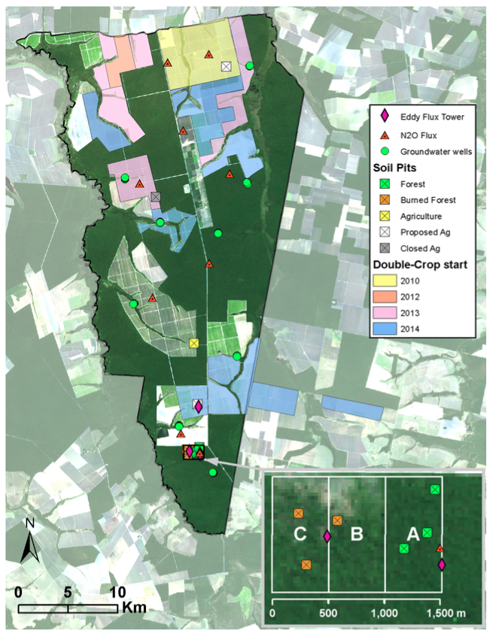

**Figure 1.** Map of study site Tanguro Ranch (courtesy Paul Leferve). Dark areas are forested parcels; light areas are agricultural fields. Soil pits (squares) sampled in this investigation include the southern three forest pits (green squares within forest block “A” in inset) and an agricultural forest pit (yellow square) in the southern half of the farm. Color overlay indicates what year soy/maize double cropping began, where applicable.

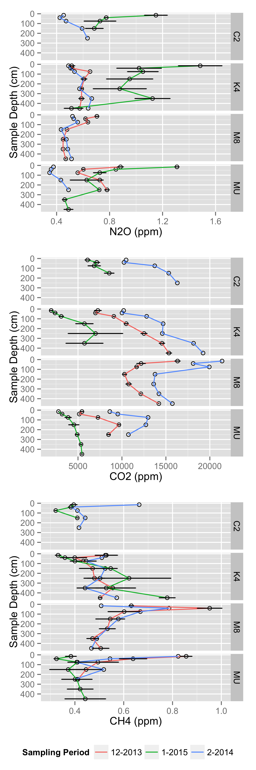

**Figure 2.** Standing presence (ppm) of trace gases in soil pore space in soil pits at Tanguro Ranch. Sampling was conducted in December 2013 and February 2014. C2, K4 and M8 are located within intact forest, while MU is located within cultivated soybean. Error bars represent the standard error.

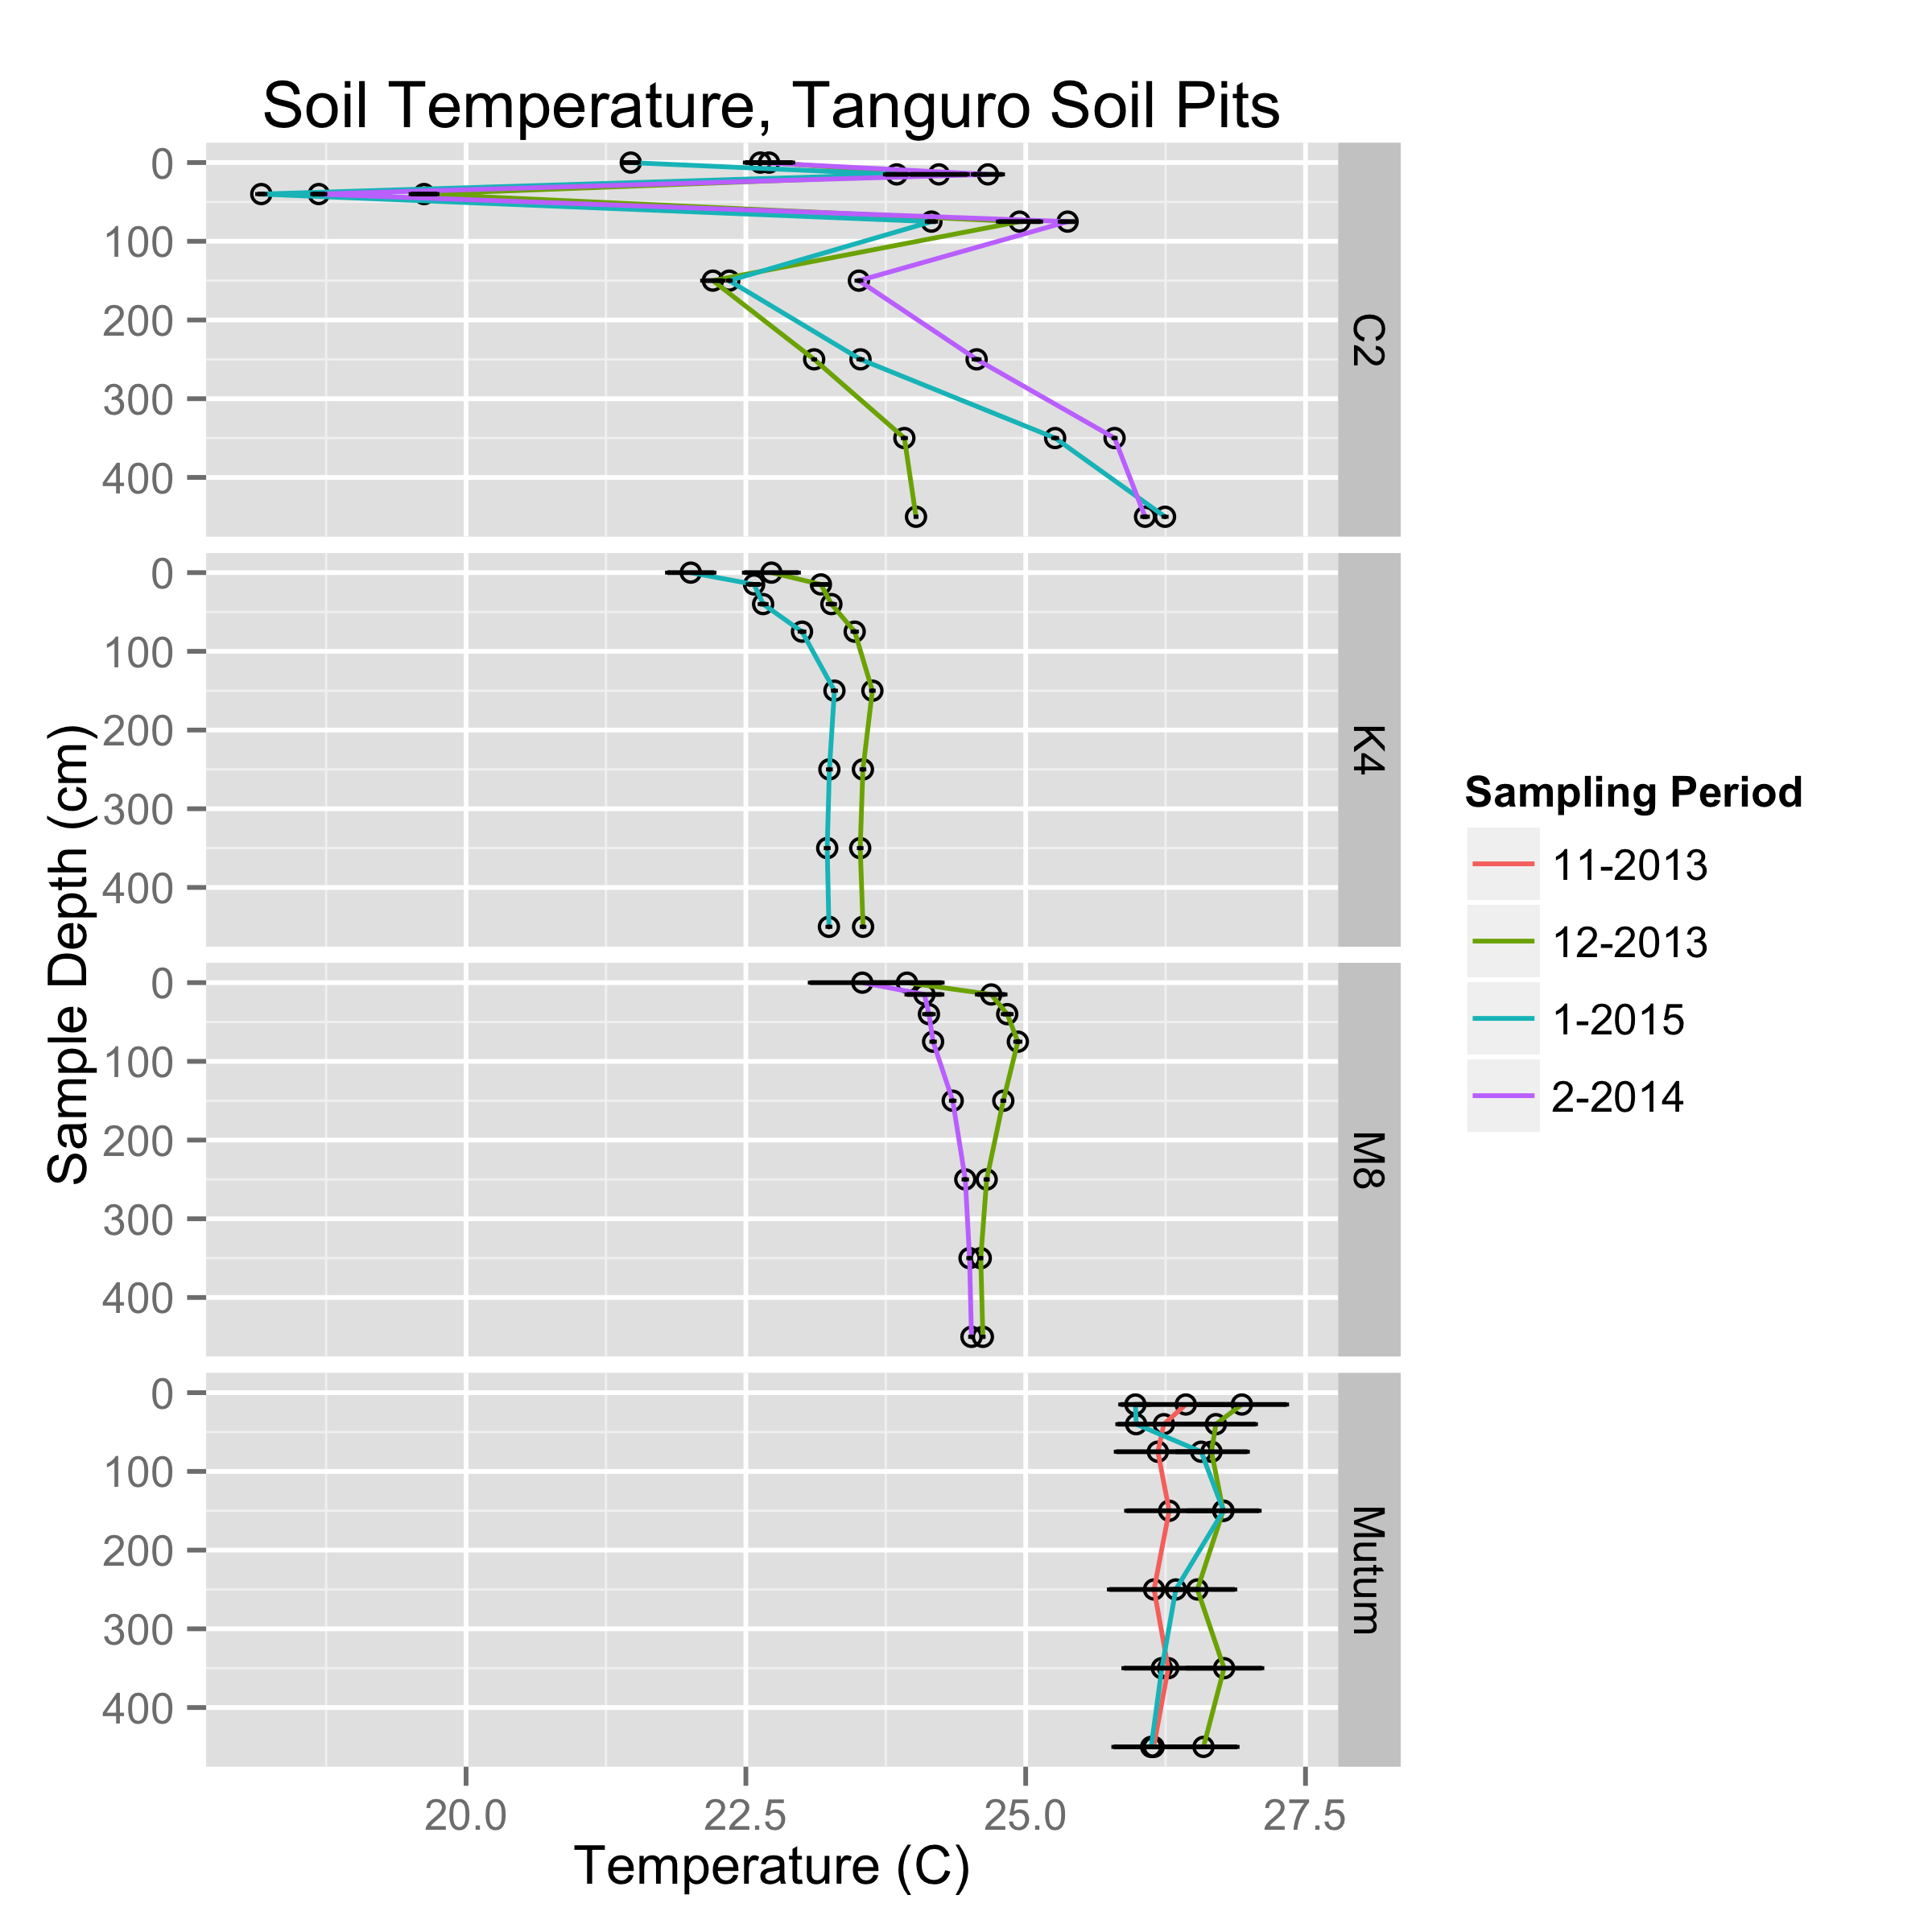

**Figure 3.** Soil temperature (C) in soil pits at Tanguro Ranch. Data is the mean and standard error of a week of thermocouple readings (taken every 6 hours) for the sampling months and a representative week earlier in the wet season (November) and later in the wet season (February) than when gas samples were collected. (C2 75cm sensor failure?)

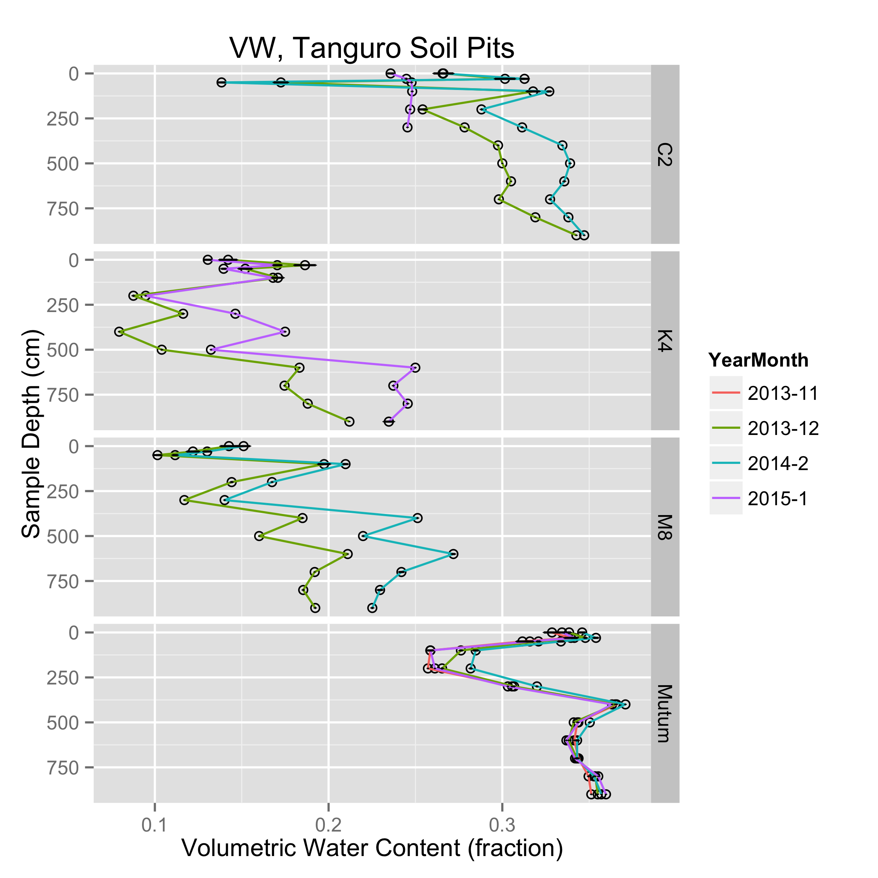

**Figure 4.** Soil volumetric water content (cm3 cm-3) in soil pits at Tanguro Ranch. Data is the mean and standard error of a week of TDR readings (taken every 6 hours) for the sampling months and a representative week earlier in the wet season (November) and later in the wet season (February) than when gas samples were collected. (C2 pit January sensor failure?)

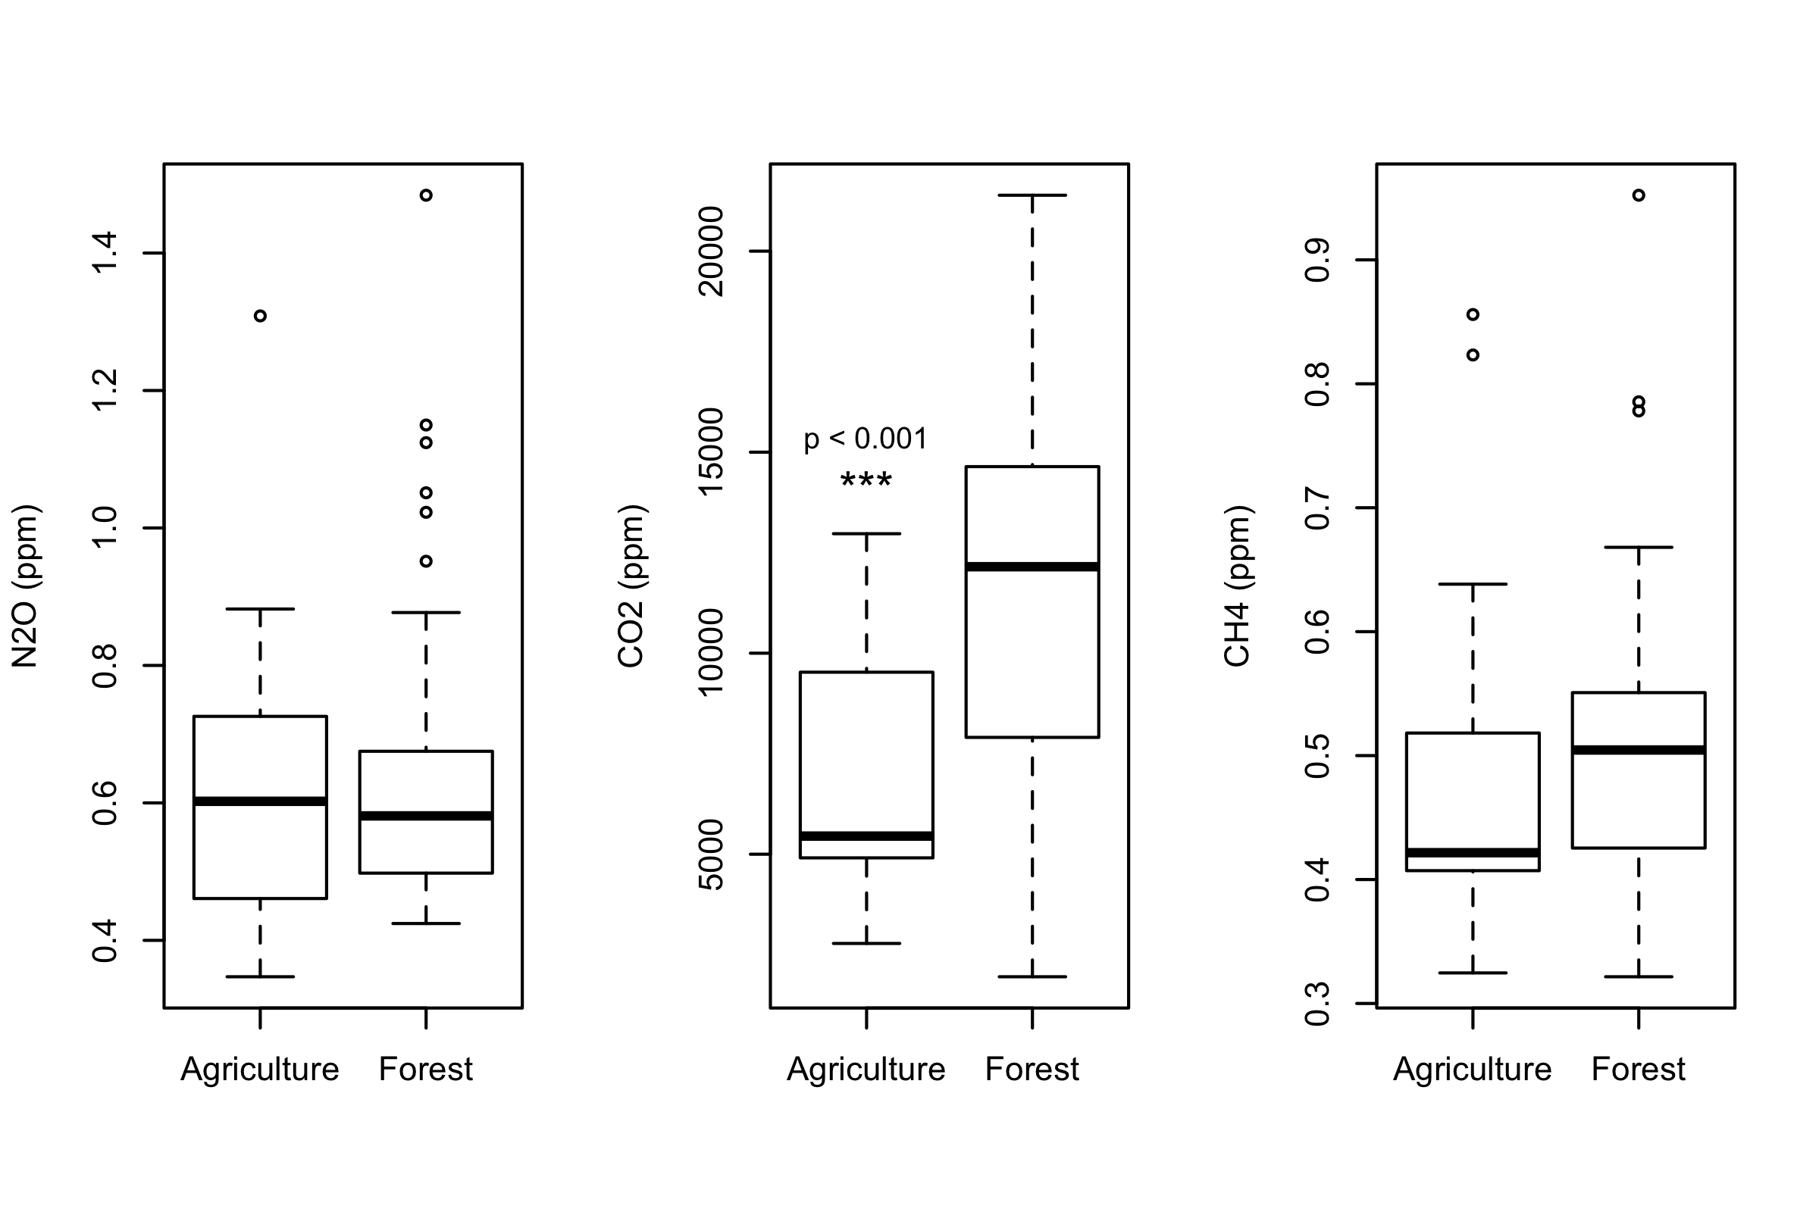

**Figure 5.** Boxplots comparing trace gas presence between land uses. Significant ANOVA results are delineated (ANOVA results were the same whether log transforming or not log transforming trace gas data).

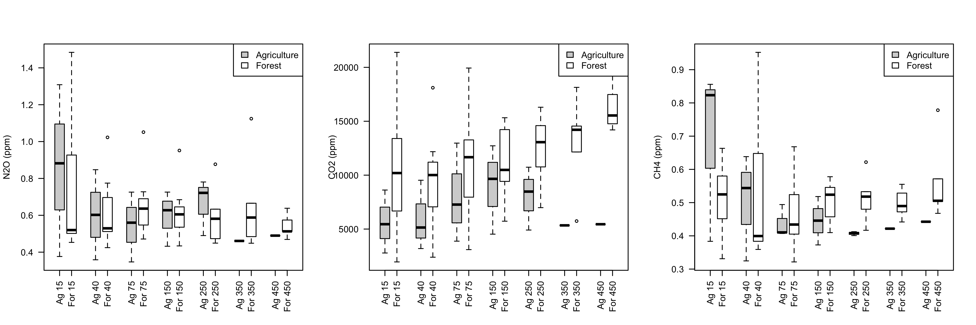

**Figure 6.** Boxplots comparing trace gas presence between land uses, grouped by soil pit depth.

|  |  |  |  |  |
| --- | --- | --- | --- | --- |
|  | Estimate | Std. Error | t value | Pr(>|t|) |
| (Intercept) | 22.99158857 | 0.342607556 | 67.1076517 | < 0.001** |
| PitIDK4 | -0.124926073 | 0.404484936 | -0.3088522 | 0.758 |
| PitIDM8 | 0.894940007 | 0.39996541 | 2.2375435 | 0.028* |
| PitIDMutum | 3.172768309 | 0.420204216 | 7.550539 | < 0.001** |
| MonthFeb | 0.172198935 | 0.39996541 | 0.4305346 | 0.668 |
| MonthJan | -0.376660572 | 0.341091648 | -1.1042797 | 0.273 |
| MonthNov | -0.441827998 | 0.574487317 | -0.7690822 | 0.444 |
| sampledepth | 0.002732436 | 0.000866944 | 3.1518041 | < 0.01* |
| *Model: meanTemperature ~ PitID + Month + sampledepth*  *Multiple R-squared: 0.6112*  *F-statistic: 15.49 on 7 and 69 DF, p-value: 5.1e-12* | | | | |

**Table 1.** Regression table with mean temperature as the response variable and pit, month and depth as the predictor variables.

|  |  |  |  |  |
| --- | --- | --- | --- | --- |
|  | Estimate | Std. Error | t value | Pr(>|t|) |
| (Intercept) | 2.50E-01 | 6.01E-03 | 41.59680003 | < 0.001** |
| PitIDK4 | -1.18E-01 | 7.33E-03 | -16.0901418 | < 0.001** |
| PitIDM8 | -1.18E-01 | 7.14E-03 | -16.54334816 | < 0.001** |
| PitIDMutum | 4.27E-02 | 6.30E-03 | 6.775752323 | < 0.001** |
| MonthFeb | 2.08E-02 | 5.93E-03 | 3.50306348 | < 0.001** |
| MonthJan | 1.77E-05 | 6.14E-03 | 0.002878346 | 0.998 |
| MonthNov | -1.72E-04 | 9.23E-03 | -0.018660816 | 0.985 |
| sampledepth | 7.38E-05 | 8.48E-06 | 8.704220879 | < 0.001** |
| *Model: meanVWC ~ PitID + Month + sampledepth*  *Multiple R-squared: 0.8459*  *F-statistic: 152.9 on 7 and 195 DF, p-value: < 2.2e-16* | | | | |

**Table 2.** Regression table with mean VWC as the response variable and pit, month and depth as the predictor variables.

|  |  |  |  |  |
| --- | --- | --- | --- | --- |
|  | Estimate | Std. Error | t value | Pr(>|t|) |
| (Intercept) | 0.679790894 | 0.381337002 | 1.7826513 | 0.082 |
| meandegC | 0.006453654 | 0.017497908 | 0.3688243 | 0.714 |
| meanVW | -0.405730261 | 0.421060028 | -0.9635924 | 0.341 |
| Month.L | -0.201082049 | 0.045564176 | -4.4131611 | < 0.001** |
| Month.Q | 0.186803752 | 0.048392842 | 3.8601525 | < 0.001** |
| sampledepth | -0.000601249 | 0.000189835 | -3.1672234 | < 0.01* |
| lm(formula = meanN2Oppm ~ meandegC + meanVW + Month + sampledepth)  Multiple R-squared: 0.5113  F-statistic: 8.997 on 5 and 43 DF, p-value: 6.563e-06 | | | | |

**Table 3.** Regression table with ppm N2O as the response variable.

|  |  |  |  |  |
| --- | --- | --- | --- | --- |
|  | Estimate | Std. Error | t value | Pr(>|t|) |
| (Intercept) | 9665.0312 | 5428.7118 | 1.7803545 | 0.082 |
| meandegC | 203.3517 | 242.4184 | 0.8388461 | 0.406 |
| meanVW | -21383.7003 | 5714.0943 | -3.7422729 | < 0.001** |
| Month.L | 3041.2511 | 660.5559 | 4.6040783 | < 0.001** |
| Month.Q | -6101.0967 | 697.3367 | -8.7491402 | < 0.001** |
| lm(formula = meanCO2ppm ~ meandegC + meanVW + Month)  Multiple R-squared: 0.7562  F-statistic: 33.34 on 4 and 43 DF, p-value: 1.144e-12 | | | | |

**Table 4.** Regression table with ppm CO2 as the response variable.

|  |  |  |  |  |
| --- | --- | --- | --- | --- |
|  | Estimate | Std. Error | t value | Pr(>|t|) |
| (Intercept) | -1.405495799 | 0.475884743 | -2.9534374 | < 0.01* |
| meandegC | 0.039118877 | 0.021836296 | 1.7914612 | 0.08 |
| meanVW | -1.189208168 | 0.525456596 | -2.2631901 | 0.029 . |
| Month.L | 0.108606157 | 0.056861244 | 1.9100208 | 0.063 |
| Month.Q | -0.077948359 | 0.060391242 | -1.2907229 | 0.204 |
| sampledepth | -0.000106424 | 0.000236902 | -0.4492303 | 0.656 |
| lm(formula = log(meanCH4ppm) ~ meandegC + meanVW + Month + sampledepth)  Multiple R-squared: 0.2891  F-statistic: 3.497 on 5 and 43 DF, p-value: 0.009698 | | | | |

**Table 5.** Regression table with ppm CH4 as the response variable.

**References and Notes:**

1. J. S. Powers, M. D. Corre, T. E. Twine, E. Veldkamp, Geographic bias of field observations of soil carbon stocks with tropical land-use changes precludes spatial extrapolation, *Proceedings of the National Academy of Sciences* **108**, 6318–6322 (2011).

2. E. Jobbágy, R. Jackson, The vertical distribution of soil organic carbon and its relation to climate and vegetation, *Ecological Applications* **10**, 423–436 (2000).

3. R. B. Harrison, P. W. Footen, B. D. Strahm, Deep soil horizons: contribution and importance to soil carbon pools and in assessing whole-ecosystem response to management and global change, *Forest Science* (2011).

4. D. C. Nepstad, C. R. de Carvalho, E. A. Davidson, P. H. Jipp, The role of deep roots in the hydrological and carbon cycles of Amazonian forests and pastures, (1994).

5. C. Rumpel, I. Kögel-Knabner, Deep soil organic matter—a key but poorly understood component of terrestrial C cycle, *Plant Soil* **338**, 143–158 (2010).

6. E. D. SOTTA *et al.*, Effects of an induced drought on soil carbon dioxide (CO 2) efflux and soil CO 2production in an Eastern Amazonian rainforest, Brazil, *Global Change Biol* **13**, 2218–2229 (2007).

7. C. Neill, M. C. Piccolo, C. C. Cerri, P. A. Steudler, J. M. Melillo, Soil Solution Nitrogen Losses During Clearing of Lowland Amazon Forest for Pasture, *Plant Soil* **281**, 233–245 (2006).

8. K. G. Eilers, S. Debenport, S. Anderson, N. Fierer, Soil Biology & Biochemistry, *Soil Biology and Biochemistry* **50**, 58–65 (2012).

9. C. Neill, M. C. Piccolo, J. M. Melillo, P. A. Steudler, Nitrogen dynamics in Amazon forest and pasture soils measured by 15 N pool dilution, *Soil Biology and …* (1999).

10. V. S. Melo *et al.*, Consequences of forest conversion to pasture and fallow on soil microbial biomass and activity in the eastern Amazon, *Soil Use and Management* **28**, 530–535 (2012).

11. M. Keller *et al.*, Soil-atmosphere exchange of nitrous oxide, nitric oxide, methane, and carbon dioxide in logged and undisturbed forest in the Tapajos National Forest, Brazil, *Earth Interactions* **9**, 1–28 (2005).

12. M. C. Piccolo, F. Andreux, C. C. Cerri, HYDROCHEMISTRY OF SOIL SOLUTION COLLECTED WITH TENSION-FREE LYSIMETERS IN NATIVE AND CUT-AND-BRUNED TROPICAL RAIN FOREST …, *Geochimica Brasiliensis* (2011).

13. M. R. Williams, T. R. Fisher, J. M. Melack, Solute dynamics in soil water and groundwater in a central Amazon catchment undergoing deforestation, *Biogeochemistry* (1997).

14. S. J. HAYHOE *et al.*, Conversion to soy on the Amazonian agricultural frontier increases streamflow without affecting stormflow dynamics, *Global Change Biol* **17**, 1821–1833 (2011).

15. M. N. Macedo *et al.*, Decoupling of deforestation and soy production in the southern Amazon during the late 2000s, *Proceedings of the National Academy of Sciences* **109**, 20120171–20120171 (2012).

16. R. DeFries, M. Herold, L. Verchot, M. N. Macedo, Y. Shimabukuro, Export-oriented deforestation in Mato Grosso: harbinger or exception for other tropical forests? *Philosophical Transactions of the Royal Society B: Biological Sciences* **368**, 20120173–20120173 (2013).

17. J. K. Balch *et al.*, Negative fire feedback in a transitional forest of southeastern Amazonia, *Global Change Biol* **14**, 2276–2287 (2008).

18. P. M. Brando *et al.*, Abrupt increases in Amazonian tree mortality due to drought-fire interactions, *Proceedings of the National Academy of Sciences* **111**, 6347–6352 (2014).

19. R. T. Venterea, M. Burger, K. A. Spokas, Nitrogen Oxide and Methane Emissions under Varying Tillage and Fertilizer Management, *Journal of Environment Quality* **34**, 1467 (2005).

20. T. J. Blasing, Recent Greenhouse Gas Concentrations, (2009), doi:10.3334/CDIAC/atg.032.

21. S. H. Riskin *et al.*, The fate of phosphorus fertilizer in Amazon soya bean fields, *Philosophical Transactions of the Royal Society B: Biological Sciences* **368**, 20120154–20120154 (2013).

22. K. Fujisaki *et al.*, From forest to cropland and pasture systems: a critical review of soil organic carbon stocks changes in Amazonia, *Global Change Biol* **21**, 2773–2786 (2015).

23. J. L. Rodrigues *et al.*, Conversion of the Amazon rainforest to agriculture results in biotic homogenization of soil bacterial communities, *Proceedings of the National Academy of Sciences of the United States of America* **110**, 988–993 (2013).

24. E. L. Madsen, Microorganisms and their roles in fundamental biogeochemical cycles, *Current Opinion in Biotechnology* **22**, 456–464 (2011).

25. E. A. Davidson, S. E. Trumbore, Gas diffusivity and production of CO2 in deep soils of the eastern Amazon, *Tellus B* (1995).

**Acknowledgements**

FIELD TEAM!!!!! IPAM TEAM!!!!! We thank M. Dolan, P. Brando and P. Leferve (**Paul should be author when we write this up?**) for technical support and assistance with figure creation. We are grateful to M. Macedo, S. Hobbie, J. Finlay, and (**who else?**) for helpful conversations. Funding was provided by a National Science Foundation Graduate Research Fellowship and a University of Minnesota Graduate Student Fellowship to C.S.O., and grants from the National Science Foundation and the Gordon and Betty Moore Foundation. Stakeholder outreach and public engagement support was provided by the University of Minnesota Institute on the Environment, and contributions by General Mills, Mosaic, Cargill, Pentair, Google, Kellogg’s, Mars, and PepsiCo. Funders had no role in study design, data collection and analysis, decision to publish, or preparation of the manuscript.

**Supplemental Figures:**

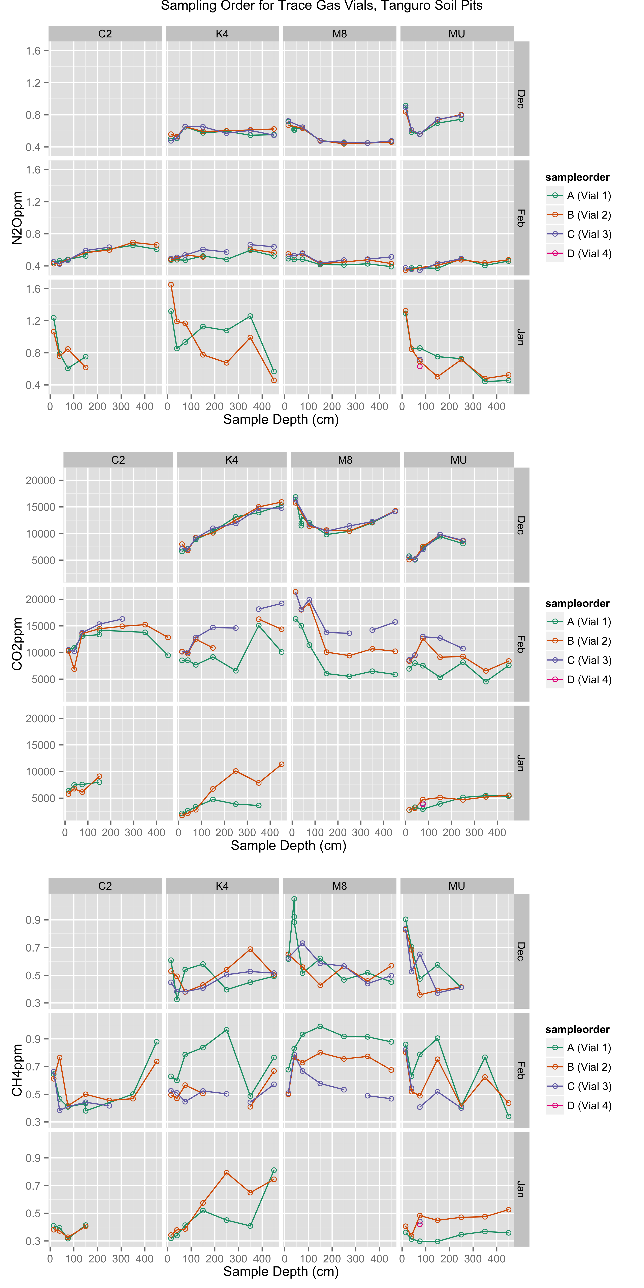

**Supplemental Figure S1.** Standing presence (ppm) of trace gases in soil pore space in soil pits at Tanguro Ranch. Colors indicate the order in which the vial was sampled (approximately 1 minute gap between samples), used to assess whether samples were in good agreement.

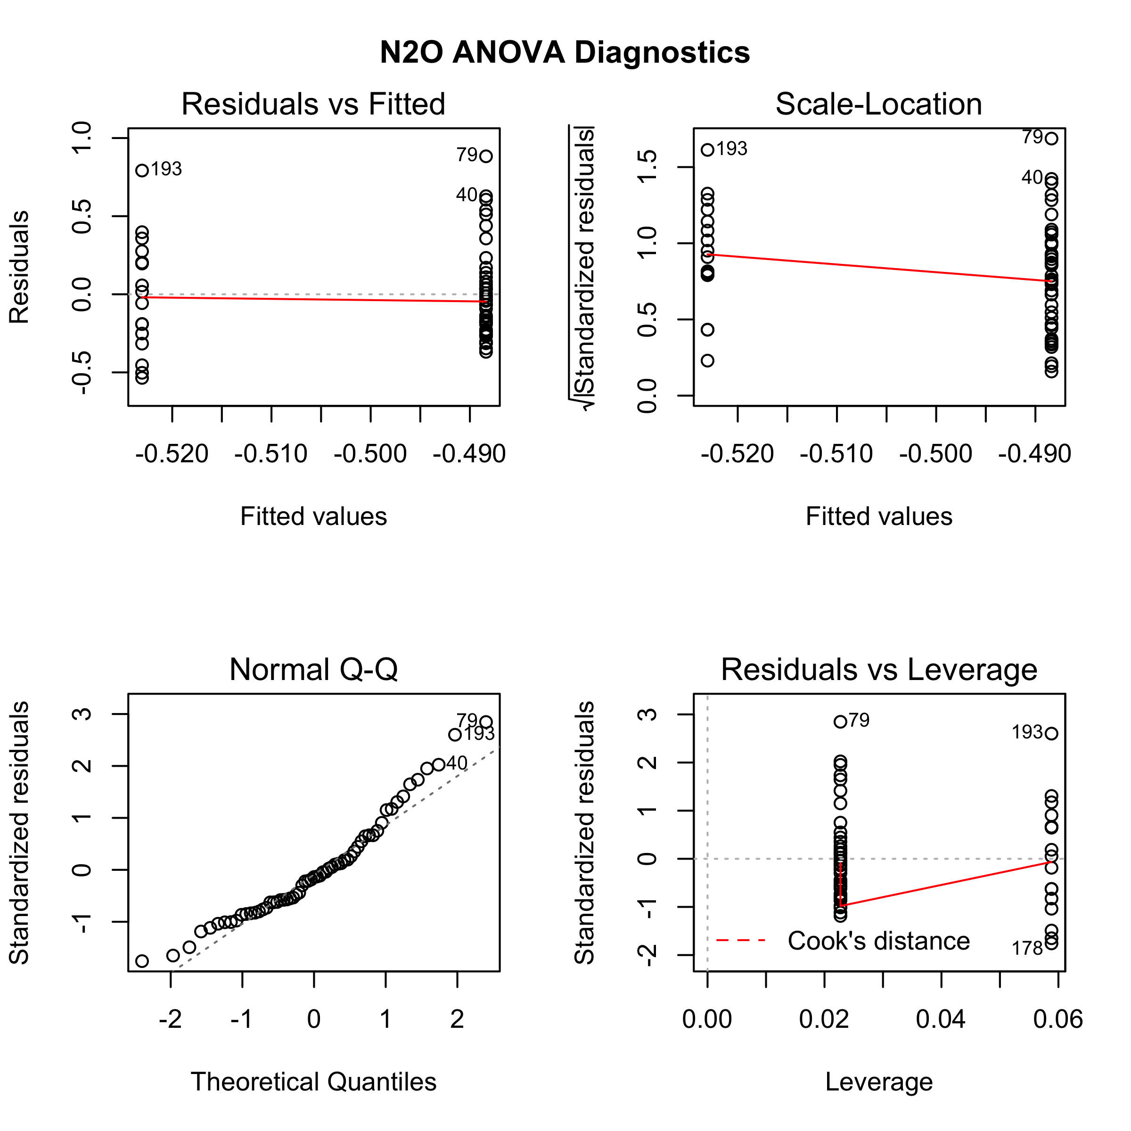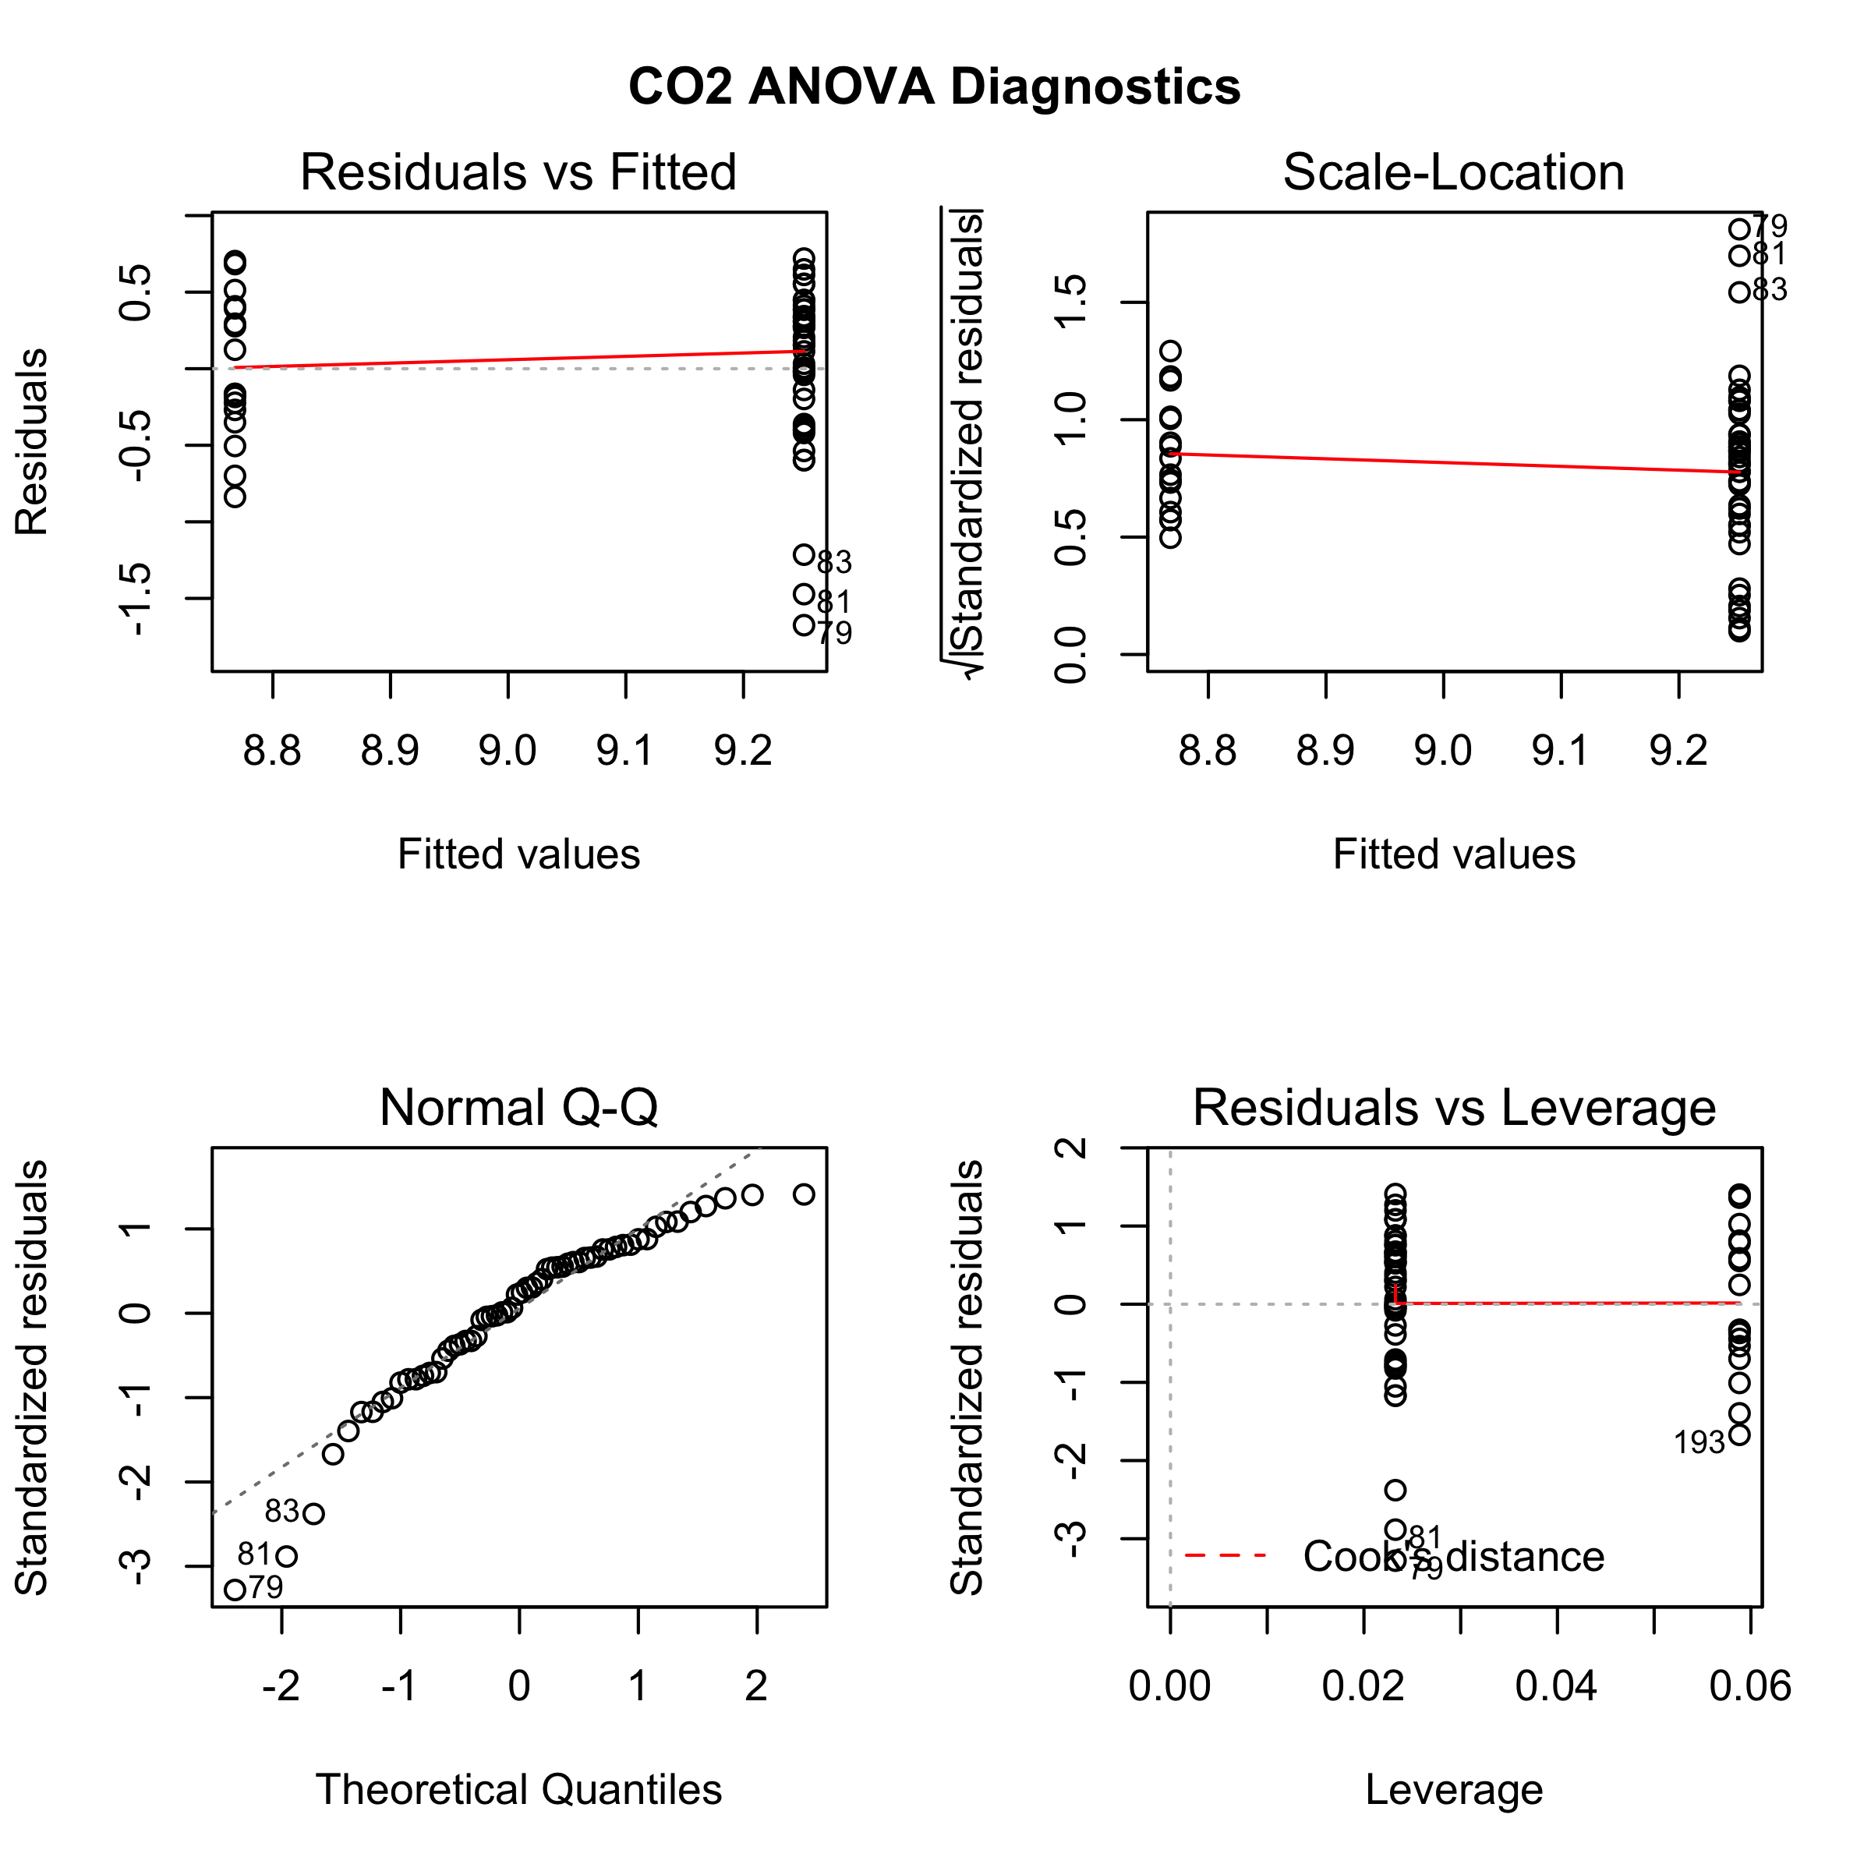

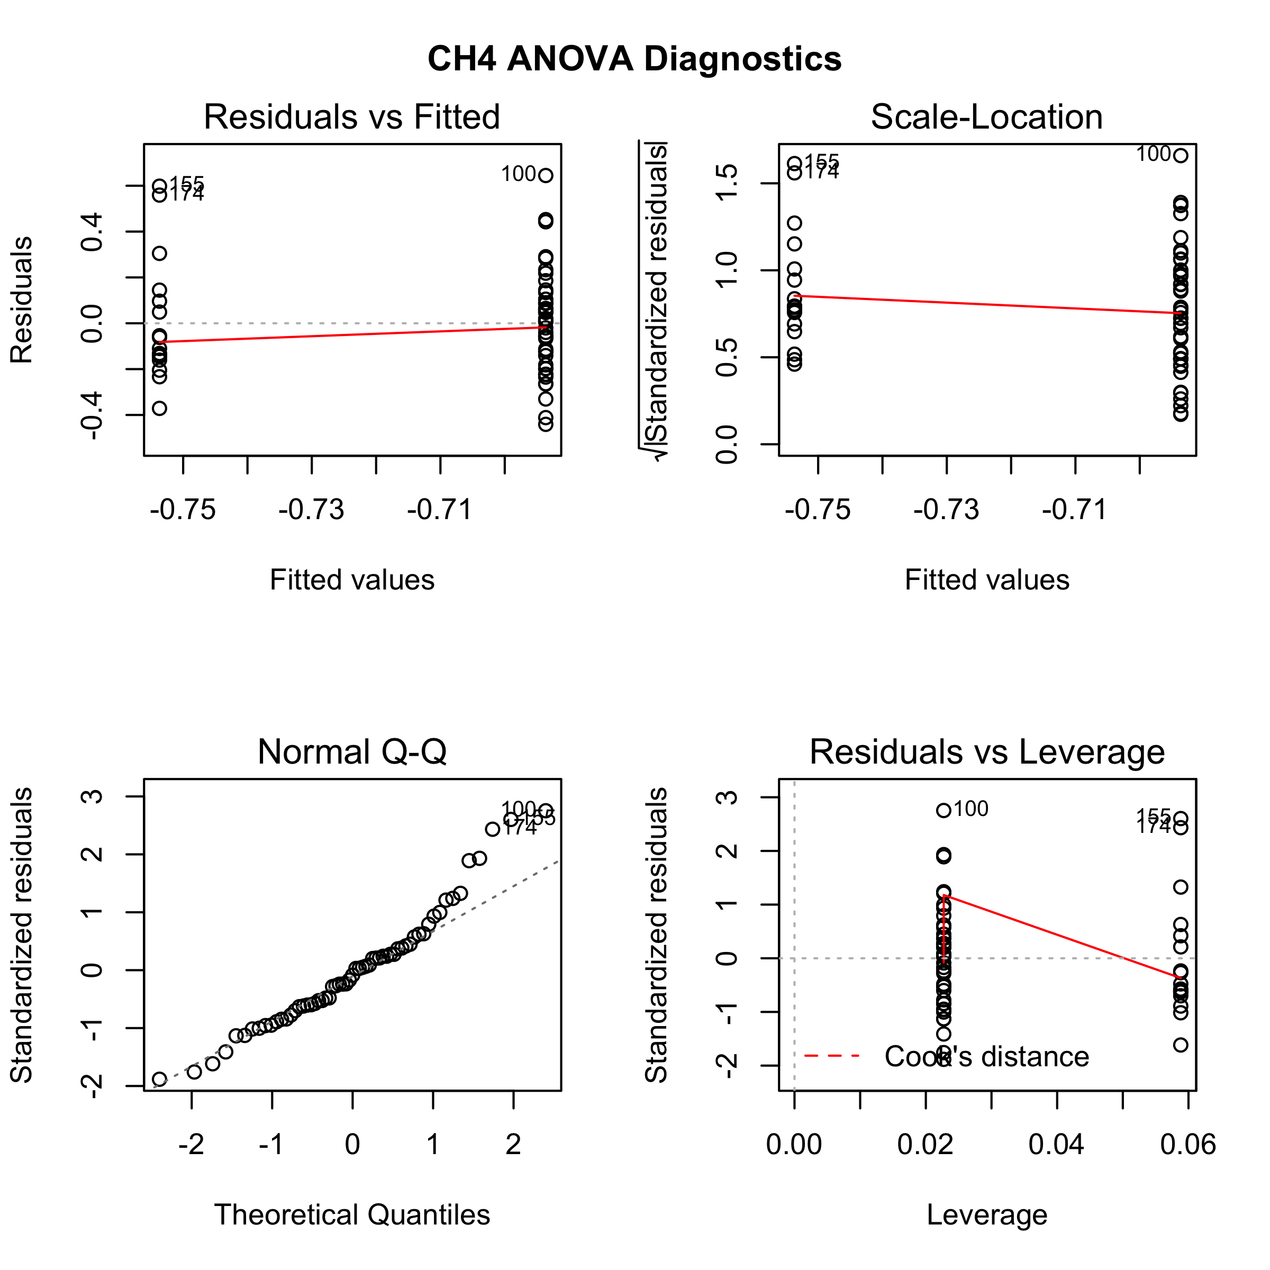

**Supplemental Figure S2.** Diagnostic plots for one-way ANOVAs comparing differences in trace gases under different land uses. In all cases, model: log(trace gas ppm) ~ land use type.